The trading behavior of NASDAQ Companies
Institution Affiliation
Name
Course title
Date

Introduction
The National Association of Securities Dealers Automated Quotation Exchange (NASDAQ) is an electronic exchange that aids investors to trade stocks on a computerized system (Parry, 2020).This system has benefits such as transparency, high speed transaction and efficiency since no physical approval is required to complete a transaction. It equally represents equities related to computer, internet companies, high-tech companies as well as other major multinational corporations dealing in finance, consumption, industrial and biotech companies. This study aims at examining the 10 most traded equities on NASDAQ which include; AMC Entertainment Holdings, Nokia Corporation, Ford Motors, Apple Inc., Inovio pharmaceutical, Black Berry Ltd, NIO Ltd, DuPont de Nemour Ltd, General Electric Company and Hecla Mining Company.
Among the major significance of NASDAQ is that, it contributes to the local and global economy by informing and advising investors and the society about the performance of companies since it is trusted and transparent. In order to achieve its major role, NASDAQ operates on data such as CPI, interest rates, GDP, inventory levels and employment (Xie, et al., 2020). Currency and trade wars directly affect companies under NASDAQ thus inflicting tariffs and barriers. NASDAQ ranks corporations based on their performance and the above named are the best according to them so far.
Analysis
In this section, I will be exploring the industries that the top 10 NASDAQ companies operate their market structures, market share, as well as their significance on the global market.
As among the top 10 NASDAQ companies, AMC Entertainment Holdings is a Canadian holding company where it shelters numerous subsidiaries in the entertainment industry. It majorly operates on providing theatrical exhibitions, food distribution, and online ticket booking and movie theatres. The entertainment industry has an oligopoly market structure that is why a company like AMC holds so many subsidiaries due to interdependence and existing barriers to entry. AMC serves a global market since entertainment consumption is not limited to one region but rather global due to advanced media outlet and broadcast. Their earnings per share in 2020 have remained constant at 12.89 and have increased for the last month by 1.58%. Their growth is concentrating on strategic planning in the academic setting where there are expert consultants equipped to take the company in that direction (Glynn, 2020).
The second on the list is the Nokia Corporation which was formerly a subsidiary of Microsoft up to 2016 after which it was sold to a subsidiary of Hon Hai/ Foxconn Technology Group for $350 million. Nokia produces android smart phones and tablets; it has started making smart TVs and is also a global leader in 5G networks. It operates from Finland but its products are consumed internationally thus making it a global player. According to Ruggiero et al., (2020), the smart phone and network industry is rather very competitive because there are many companies, freedom of entry and exit, homogenous goods and fair profits. Nokia has in two rounds been able to raise 750m Euros the latest round being 3 Dec, 2018 Post-IPO Debt. The company has 2 investors namely Nordic Investment Bank and European Investment Bank. Their diversity investments include Skorpios Technologies founded by women.
Thirdly, Ford Motor Company is an American multinational corporation that makes automobiles which was founded in 1903 by Henry Ford. Ford has a wide array of vehicles it produces from SUVs, sports cars, trucks, hybrid and electric cars making it a global producer of automobiles since the variety caters for different classes of consumers, different purposes and climate. According to Wang, et al., (2021), the automobile industry operates under collusive oligopoly structure where a few global companies determine the direction the whole industry takes when they produce their products. Those companies which have made it in the industry earn high profits because they have substantial control over the industry. The ford stock is selling at US $10.86 which results to a profit of +0.28% which is a raise of 0.03.
Fourthly, Apple Inc. is American multinational technology companies that designs, develops and sell household electronics, computer software, cell phones and online services. As much as Apple shares the same market with Nokia, it has proven to be more successful due to its distinct market derived by successful branding. Consequently, their hardware is distinct from those of the competitors but however they have made accessories that are compatible with third party such as Nikon and Canon cameras. The company prides on high quality products, individual software and despite the products being so expensive, defective products do not seize to exist (Tien, 2020). Apple’s NASDAQ stock is selling at US$ 134.99 which is a rise of 0.85 and a profit margin of +0.63%.
More so, Inovio Pharmaceuticals Inc. is an American biotechnology company majoring on research, development and commercialization of synthetic DNA products that are used to treat cancer and also infectious diseases. Given the nature of the market, their products are on high demand thus the company operates under contestable market. Their work is of great relevance to the word since the diseases they are trying to treat have no cure yet (Kraynyak and Morrow, 2020). Their stock at NASDAQ is selling at US$ 15.09 which has gone down by 1.87 leading to a profit margin of -11.03%. The company announced closing of public offering of common stock and full exercise of underwriter’s opinion to purchase additional shares.
Additionally, Black Berry is a Canadian multinational company that develops software, mobile phones and internet services; a subsidiary of TCL Communication. It operates in a competitive market where the competitors include JAMF, Sony and Motorola Solutions. Their stock at NASDAQ is selling at ARS 605.00 which is a downfall of 148.50 resulting to a negative profit margin of 19.71%.
To add on that, NIO Ltd is a Chinese company that designs and develops high quality, high performance electric cars. The company is involved in FIA Formula E championship which is a first single-seater electric racing car series promoted by Formula E Holdings. The market is very competitive now that the automobile industry is revolutionizing towards green energy and electric cars are a big contributor in the movement. NIO’s main competitor is Tesla, an American electric vehicle and clean energy company whose stock is selling at 872.79 which is a rise of 32.98 which resulted to a rise in profit margin to 3.93%. NIO stock is selling at US$ 55.77 which decreased by 1.22 which has reduced the profit margin by 2.14%. According to analysts three months review the average price has been at a target of $65.28 with a high estimate of $80.3 and a low of $ 46.
Next, DuPont de Nemour Inc. develops tech-based materials used in the fields such as electronic and imaging, science and nutrition, safety and construction, and transport and industrial. It is a parent company to several subsidiaries that deal in the same materials in the United States. Nevertheless, General Electric Company is an American multinational conglomerate corporation that operates through aviation, healthcare, power, addictive manufacturing and venture capital. DuPont has strength in innovation, customer relations and profound operating concepts which translates to high returns and good performance thus being consistent. The company’s stock is selling at $76.40 which resulted with a rise of $3.26 which resulted in an increase in the profit margin of 4.46%.
Lastly, I will expound on Hecla Mining Company deals in precious metals where they trade on behalf of their shareholders through discovery, developing, acquiring and producing minerals at a profit, Tremblay, et al, 2020. It is a leading low cost producer of silver operating in Alaska, Idaho and Mexico as well as gold producer in Canada and Nevada. With the aid of an outstanding development program the company has grown continuously and the reserve base for future production adding up to 212 million ounces of silver and 2.7 million ounces of gold reserves reached at by lowest price assumption for the industry. 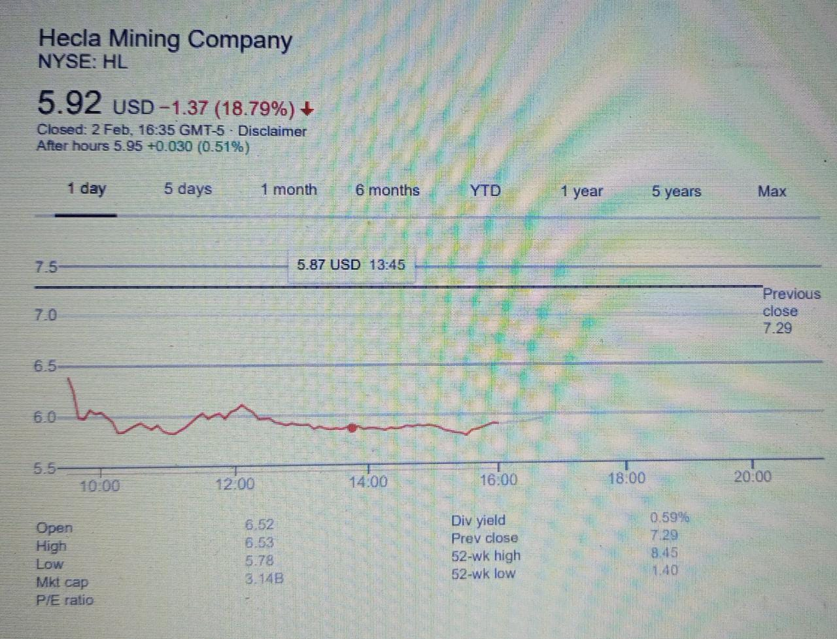
Hecla Mining Company has competitor like Gran Colombia which also deals in precious metal and mineral industry which generates revenue of $ 353.7m less than Hecla. They pay a dividend of 0.04 per share annually with a collective dividend payout of -30.77% of its earnings as dividends. It has been estimated that the company has a media target of 6.75 with a high estimate of 6.53and a low of 5.78. Hecla limited is a buy. Below is a graph of Hecla Mining Company stock for the last 6 months.
Conclusion (1 paragraph)

Appendix
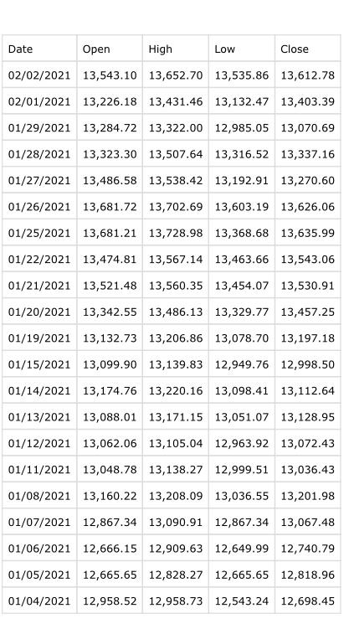

References
Parry, T. (2020). NYSE, AMEX, and NASDAQ Stock Exchange Returns. Available at SSRN 3730161.
Xie, W., Paulo Vieito, J., Clark, E., & Wong, W. K. (2020). Could mergers become more sustainable? A study of the stock exchange mergers of NASDAQ and OMX. Sustainability, 12(20), 8581.
Glynn, S. (2020). International Cooperation and the Interaction of Socialist and Capitalist Economies. In The Economic Logic of Late Capitalism and the Inevitable Triumph of Socialism (pp. 113-117). Palgrave Macmillan, Cham.
Ruggiero, S., Kangas, H. L., Annala, S., & Ohrling, T. (2020). ‘Life after Nokia?’Business model innovation and niche upscaling in the emerging Finnish demand response industry.
Wang, Z., Li, W., Bian, K., & Yang, S. (2021). Analysis of Improving the Future Business Policy of Ford Motor Company. World Scientific Research Journal, 7(1), 51-55.
Tien, N. H. (2020). International distribution policy comparative analysis between samsung and apple. International Journal of Research in Marketing Management and Sales 2019, 1(2), 24-27.
Kraynyak, K., Morrow, M., & Sylvester, A. J. (2020). U.S. Patent Application No. 16/612,556.
Tremblay, T., Sasseville, C., & Godbout, P. M. Geochemistry and mineralogy of glacial sediments, north of Fury and Hecla Strait, northwestern Baffin Island, Nunavut.

